**Assignment 8**

Use your own database and provide the screenshot of the query and output.

Q1. Write a view to join Product and product line to group by Productline to show the sum of MSRP price

Q2. Write a query to show which products are making good business for the organization based on which customer has the order with the highest amount of money spent.

SELECT *, (quantityOrdered * priceEach) as totalPrice  
FROM (PRODUCTS NATURAL JOIN  
(orderdetails))  
WHERE (quantityOrdered * priceEach) IN (SELECT MAX(quantityOrdered * priceEach)  
FROM orderdetails);

Q3. Write a stored procedure to pass a product to find if there is any order on that product or not

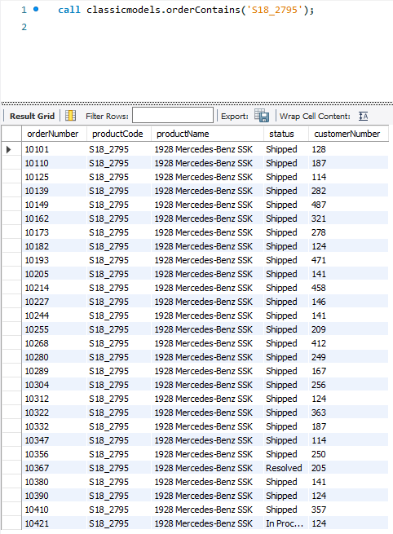

Q4. Create a new field called ‘Rating’ and give a scale in 1-10 order for best to worst depending on how the product has done the business (this will not be graded, do it only if you know)

Hint – which product sold the most and least. Write a cursor to give the rating in new fields

Q5. Write a SP , pass customer number to find the customer has paid the for their order or not.

Q6. Write a SP to find which products don’t have orders yet. Create a field (Boolean) on Product table to hold a flag. Update this field to with 1/0 value to say the products have no order. 0 for no orders and 1 for yes, has orders. Use temp table.

